Contents
1 Trigger Variable Evaluation 2
1.1 MCSI — in-sample and out-of-sample regime classification 2
1.2 Why MCSI thresholds are unstable 2
1.3 All candidates evaluated 4
2 Global OECD CCI — Regime Classification 5
2.1 S&P 500 — country-specific US CCI (included for comparability with the original paper) 5
2.2 Admissible markets — Global OECD CCI 5
2.3 Cross-market efficiency ranking 7
3 Horizon Return Test 8
3.1 Early versus late EXP 8
4 Current Market Assessment — May 2026 9

1 Trigger Variable Evaluation

1.1 MCSI — in-sample and out-of-sample regime classification
- MCSI (Michigan Consumer Sentiment Index) was the original trigger used and tested on S&P 500 and FTSE 100
- Option A: In-sample (1978–2015): thresholds c1=59.7, c2=107.3 produce plausible results — dot-com bubble flagged as EXP, some MR episodes visible
- Option B: Out-of-sample (post-2015): every month classified MR from August 2025 onwards, even as S&P 500 made all-time highs during the AI rally — economically implausible
- Root cause: c1=59.7 was anchored to GFC lows in 2008-09. Post-COVID MCSI sits in the 60s-70s for unrelated reasons (inflation, political uncertainty), mechanically triggering the MR threshold
- This is threshold staleness due to applying a crisis-era threshold to a structurally different environment

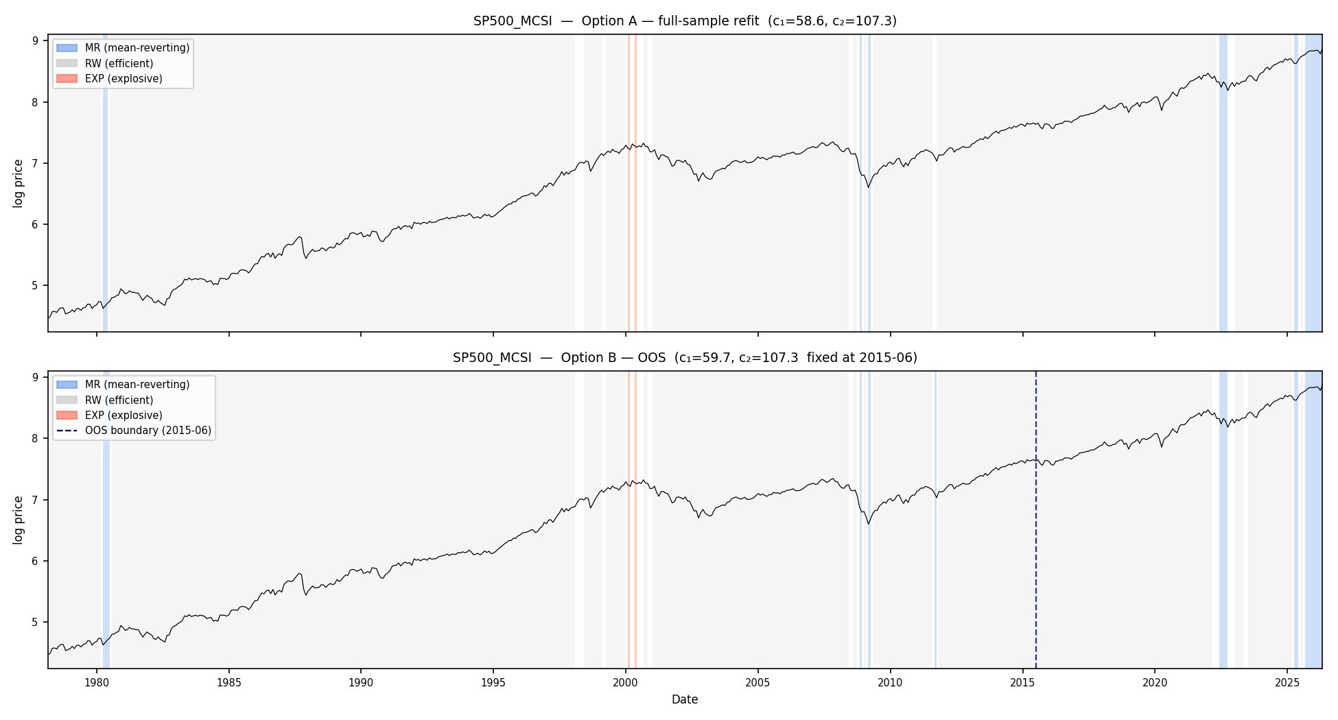  S&P 500 + MCSI. Dot-com barely registers as EXP (thin red sliver). Post-2015 extension (right of dashed line) shows MR cascade | 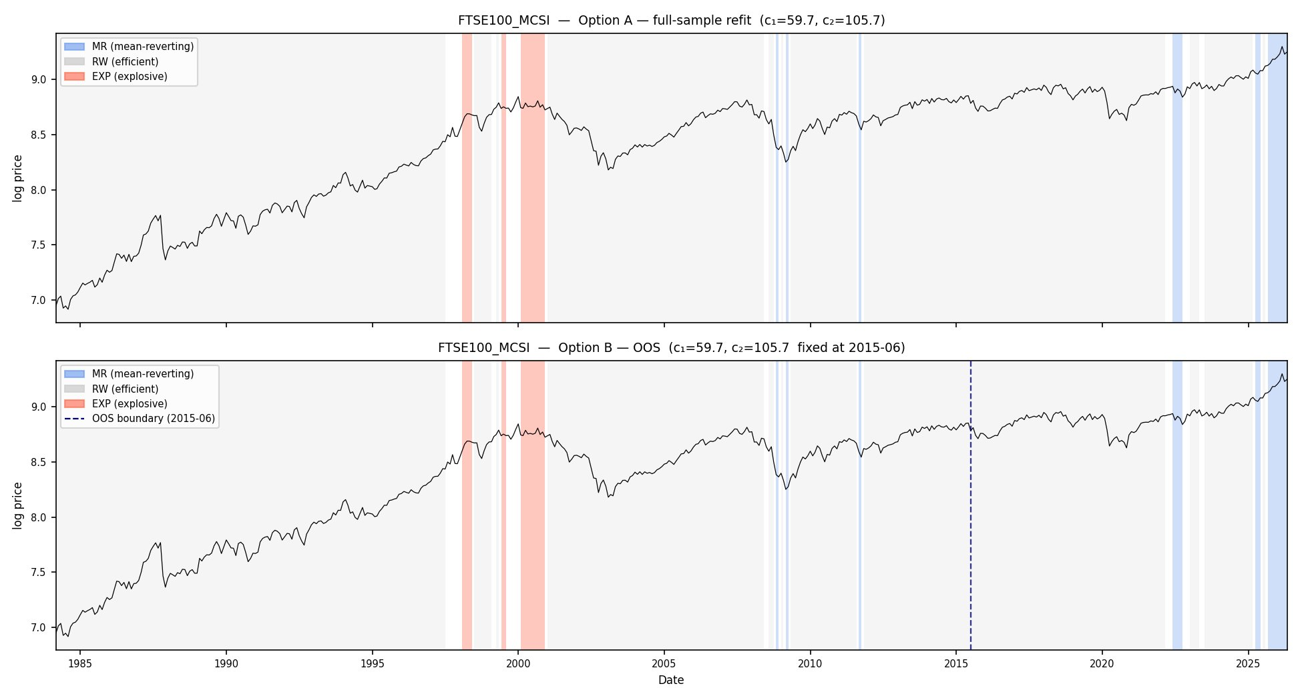  FTSE 100 + MCSI. Same pattern: sparse EXP, fragmented MR episodes, and a persistent MR cascade in the post-2015 out-of-sample period.

1.2 Why MCSI thresholds are unstable
- Rolling 10-year window estimation reveals the problem: MCSI thresholds swing 46 units across windows
- c1 sits around 90 before GFC, collapses to 58 when 2008 enters the window, then drifts back up as GFC rolls out — the threshold simply tracks the worst crisis in the current window
- OECD CCI thresholds by contrast move fewer than 5 units across the same 35 years, because the OECD amplitude-adjustment normalisation re-anchors each country to its own long-run mean of 100
- A threshold that means different things in different windows cannot support credible out-of-sample bubble calls

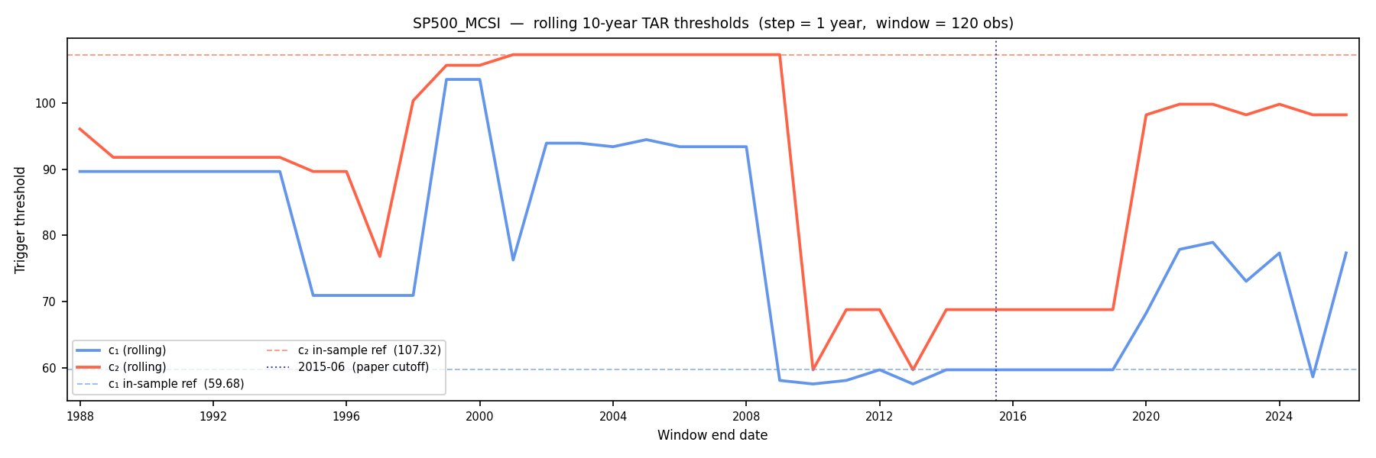  S&P 500 + MCSI: c1 ranges 46 units. Cliff-drop from 93 to 58 in 2008 when GFC enters window. | 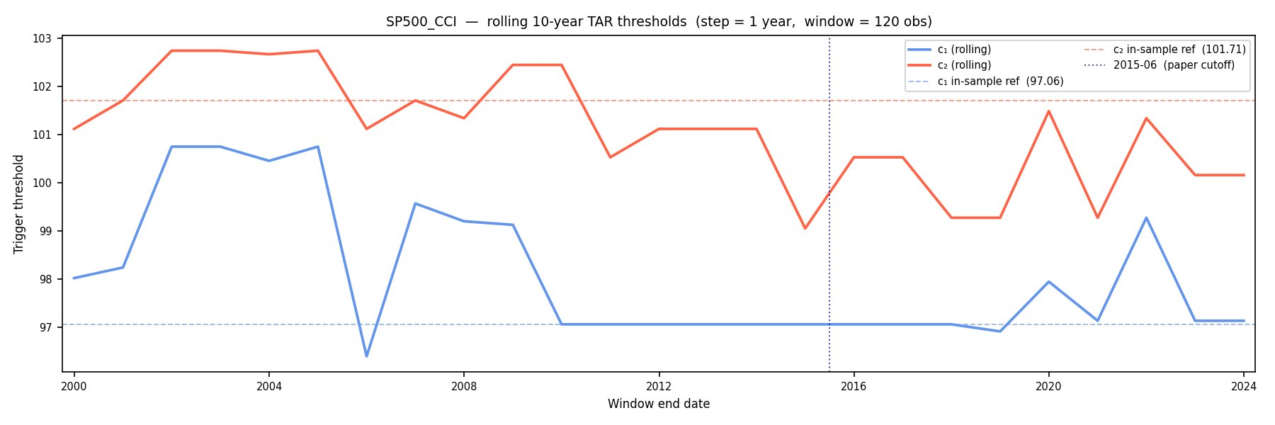  S&P 500 + US CCI: c1 ranges only 4.4 units across the same 35 years. Distributionally stable.

The global OECD CCI rolling window (below) shows the same stability at the aggregate level, confirming the normalisation holds when country CCIs are GDP-weighted together.
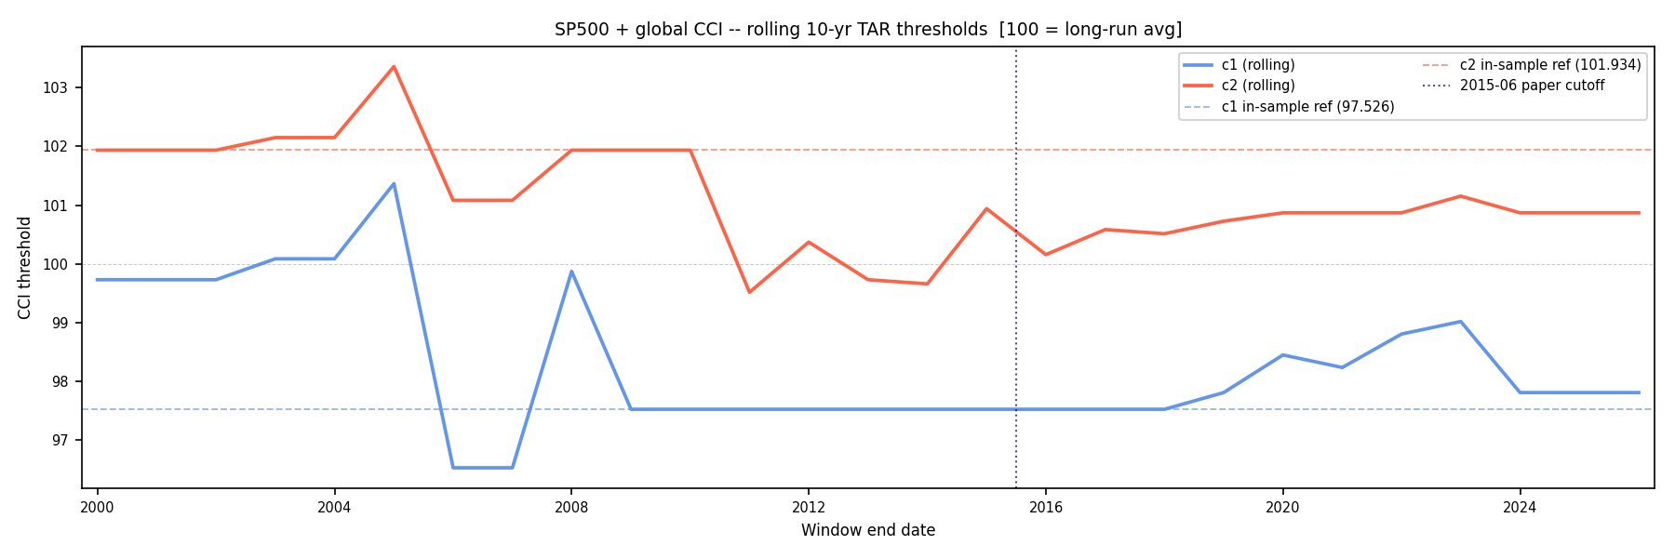
S&P 500 + Global OECD CCI: c1 range = 4.8 units, c2 range = 3.8 units. Nearly identical stability to country-specific CCI, confirming OECD normalisation works at the aggregate level.

1.3 All candidates evaluated
- Six triggers were tested against four requirements: exogeneity (equity returns must not Granger-cause the trigger), threshold stability, both-tailed coverage (must capture EXP and MR), and global applicability
- Every equity-price-derived trigger (CAPE, SPY lagged) fails exogeneity — global equity markets are contemporaneously correlated, so lagging does not help
- Financial market volatility triggers (VIX, BAA spread) are one-tailed — they spike on fear but compress during euphoria, so bubbles inflate under low VIX and the EXP state cannot fire
- ANFCI appears numerically stable but is economically degenerate post-2010: the easy-money era pushes thresholds near zero, classifying European markets as EXP 80-90% of the time
- Global OECD CCI is the only candidate meeting all four requirements — and because all component series are amplitude-adjusted to 100 = long-run mean, every market in the panel uses the same single metric on a directly comparable scale

Trigger | Exogenous | Threshold stable | Both-tailed | Global | Outcome
MCSI | Yes (US only) | No — 46-unit range | Yes | No | Rejected. GFC-anchored thresholds produce spurious MR cascade post-2020.
VIX | Yes | Moderate | No — fear only | Yes | Rejected. Structurally one-tailed; EXP cannot fire during bubble inflation.
BAA spread | Yes | Yes | No — euphoria mild | Yes | Rejected. Euphoria compression 0.56pp vs GFC spike 3.7pp — too weak for threshold geometry.
ANFCI | 9 of 23 fail | Poor post-2010 | Partial | Yes | Rejected. EXP proportions 80-90% for European markets — degenerate, not genuine bubbles.
CAPE | No — S&P endogenous | No — 21-unit range | Yes | Partial | Rejected as primary. Useful as second-stage characterisation variable only.
Global OECD CCI | 14 of 23 pass | Yes — 4.8-unit range | Yes | Yes | Selected. All four requirements met. Single normalised metric, same scale for every market.

2 Global OECD CCI — Regime Classification
The Global OECD CCI (CSCICP03OECDm) is a GDP-weighted aggregate of all 38 OECD member countries' consumer confidence indices. Each country's CCI is amplitude-adjusted so that 100 = its own long-run average. This means c1 ≈ 97.7 means the same thing in every country: sentiment is in its lower tail relative to domestic norms. One series, one set of thresholds, directly comparable results across 23 markets.
- Exogeneity gate: reverse Granger tests run for all 23 markets. 14 pass (equity returns do not predict the global CCI). 9 fail — these are the most globally integrated markets (S&P 500, FTSE 100, DAX, Nikkei, TSX, SMI, AEX, IPC, JKSE) whose equity performance is large enough to move the global aggregate
- For S&P 500 and FTSE 100, country-specific OECD CCI is used instead — these pass exogeneity because domestic survey responses are driven by the real economy rather than equity prices
- Estimated thresholds: c1 = 97.67, c2 = 101.93. Both-tails confirmed: dot-com EXP (CCI above 101.9 in 1999-2001), GFC MR (CCI below 97.7 in 2008-09)
- Two options run in parallel: Option A re-estimates thresholds on the full sample, Option B applies thresholds fixed at 2015. Where both agree, the classification is robust to sample window choice

2.1 S&P 500 — country-specific US CCI (included for comparability with the original paper)
S&P 500 uses country-specific US OECD CCI rather than the global aggregate, as it fails the global CCI exogeneity gate. This is the cleanest result in the study: both options produce identical thresholds.
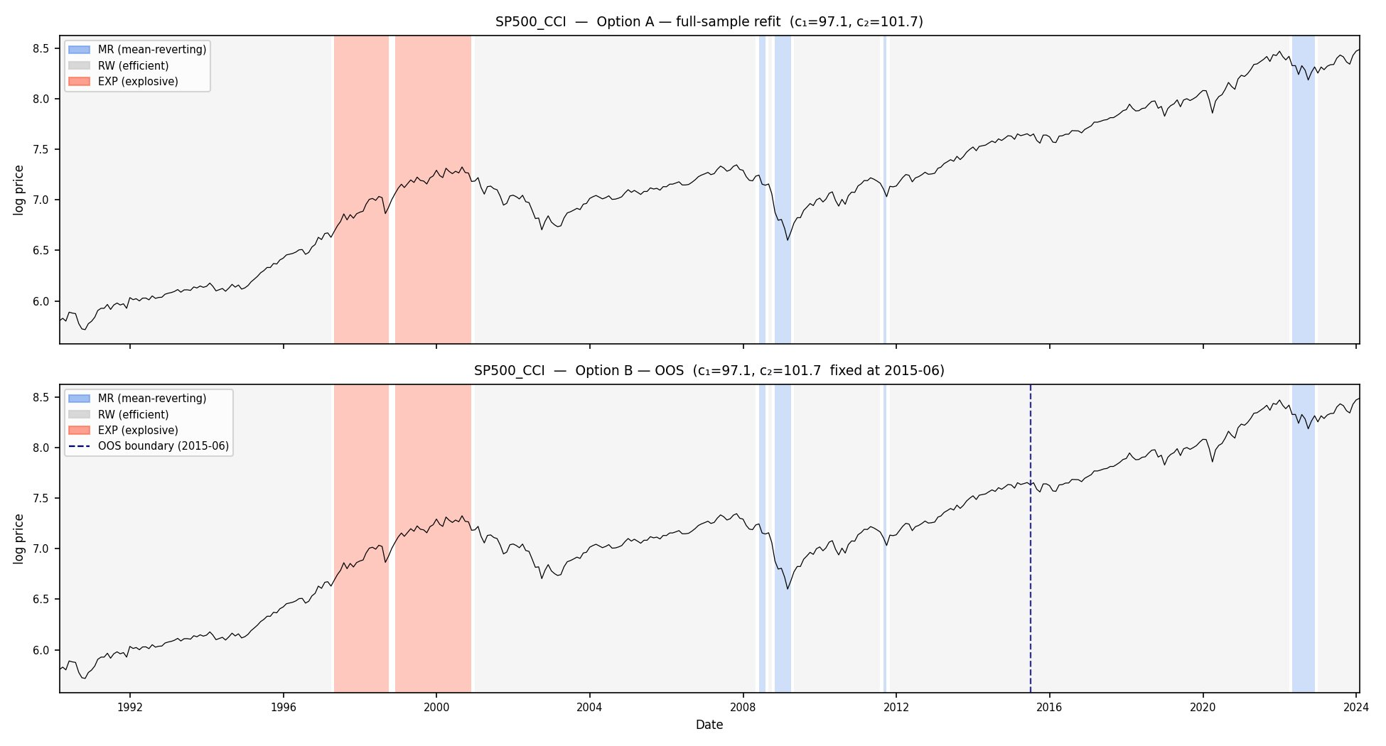
S&P 500 + US OECD CCI. c1=97.1, c2=101.7 identical across Options A and B. Sustained dot-com EXP (1997-2001), GFC MR (2008-09), MR returns from late 2022 onwards (inflation shock then tariff shock). The AI rally 2023-2024 is correctly classified as RW — not a global sentiment bubble.

2.2 Admissible markets — Global OECD CCI
The following four markets are representative of the admissible panel: TSX (developed, Canada), AEX (developed, Europe), TWSE (Asian tech-heavy) and Bovespa (emerging market, Brazil). All four pass the exogeneity gate and use the same global CCI trigger with the same thresholds.
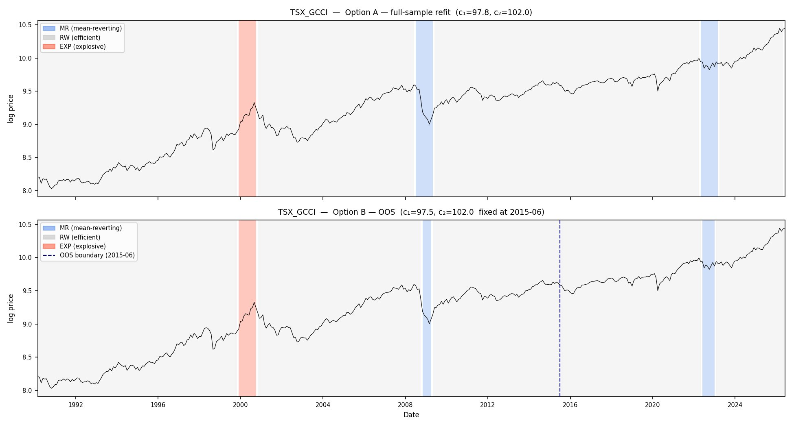  TSX (Canada) + Global CCI. c1=97.8, c2=102.0. Both-tails: dot-com EXP, GFC MR. Options A and B agree closely. Currently MR (tariff shock). | 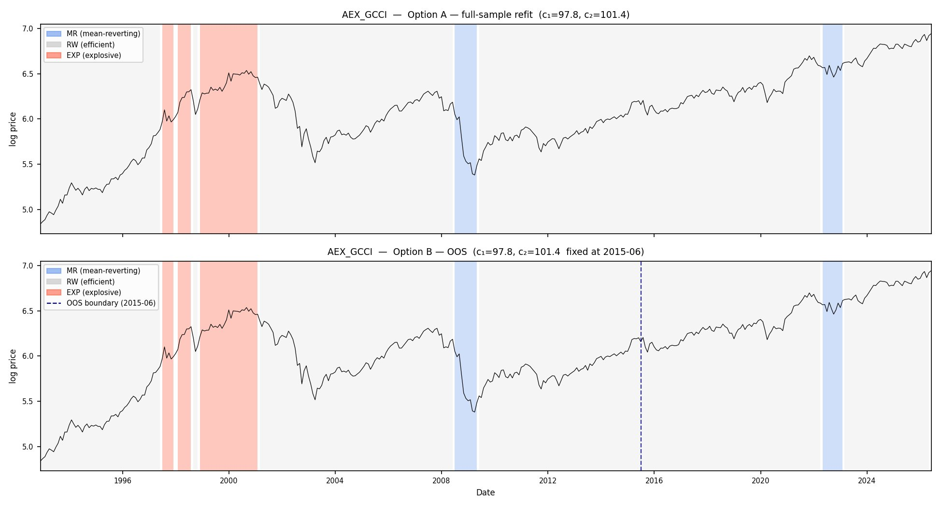  AEX (Netherlands) + Global CCI. c1=97.8, c2=101.4. Both-tails confirmed. Options A and B agree. Currently MR.

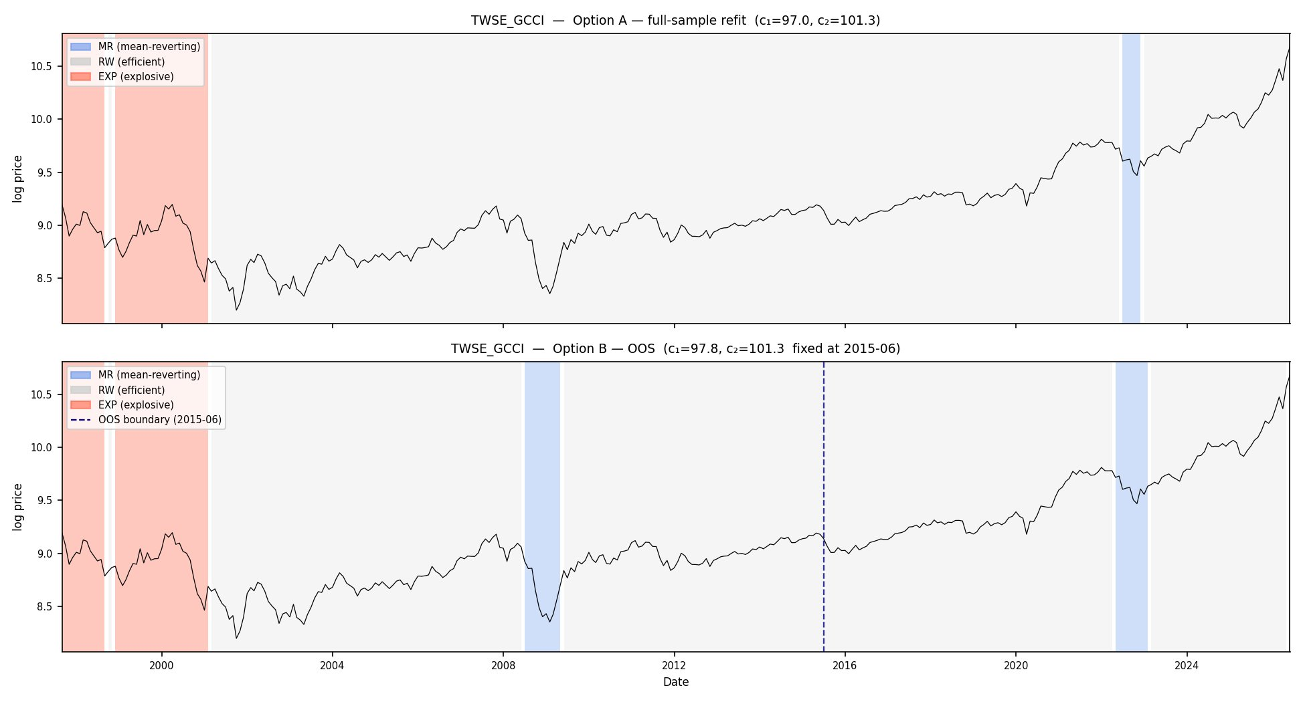  TWSE (Taiwan) + Global CCI. Dot-com EXP visible. Taiwan is a semiconductor-heavy market — global sentiment cycles are especially visible here. | 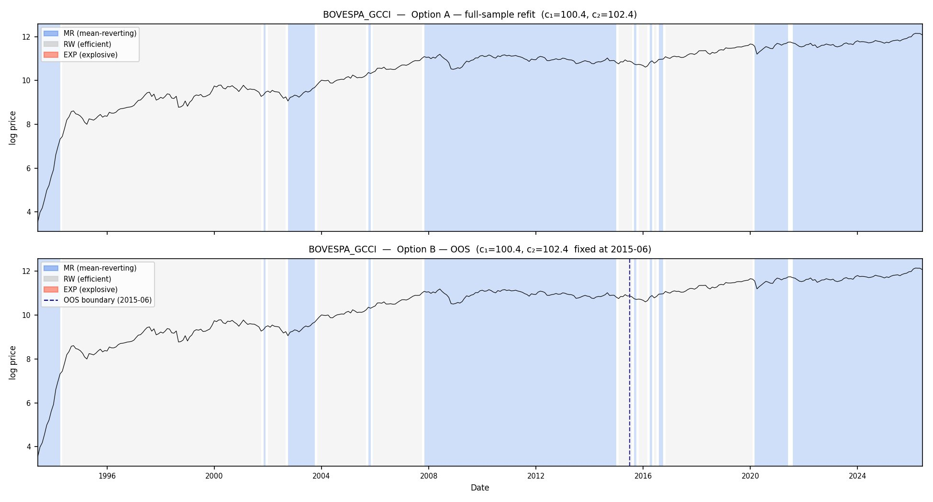  Bovespa (Brazil) + Global CCI. c1=100.4, c2=102.4. Predominantly MR throughout history — Brazil is more sensitive to global stress than to global euphoria.

2.3 Cross-market efficiency ranking
- The proportion of time in statistically significant inefficient states (MR + EXP) gives a cross-market efficiency metric —results are extended to 13
- Developed markets are most efficient: S&P 500 at 6.7%, FTSE 100 at 9.2%, TSX at 7.8%
- Emerging and smaller markets are less efficient: KOSPI 30.9%, Shanghai 48.0%
- Beta EXP is negative for every single market without exception — EXP episodes are always followed by price corrections, confirming the core TAR prediction across all geographies

Market | Country | %MR | %RW | %EXP | % Inefficient | Beta EXP
S&P 500* | USA | 3.9 | 93.3 | 2.8 | 6.7 | −0.786
TSX | Canada | 5.3 | 92.2 | 2.5 | 7.8 | −0.215
FTSE 100* | UK | 4.1 | 90.8 | 5.0 | 9.2 | −0.843
STI | Singapore | 5.7 | 89.2 | 5.0 | 10.8 | −0.313
TA125 | Israel | 6.9 | 87.6 | 5.5 | 12.4 | −0.192
Hang Seng | Hong Kong | 10.1 | 87.4 | 2.5 | 12.6 | −0.865
SMI | Switzerland | 2.8 | 86.4 | 10.8 | 13.6 | −0.179
IBEX35 | Spain | 2.0 | 86.0 | 11.9 | 14.0 | −0.150
JKSE | Indonesia | 5.1 | 85.0 | 9.9 | 15.0 | −0.259
AEX | Netherlands | 5.5 | 84.6 | 9.9 | 15.4 | −0.111
IPC | Mexico | 27.1 | 70.3 | 2.7 | 29.7 | −0.827
KOSPI | South Korea | 18.4 | 69.1 | 12.5 | 30.9 | −0.089
Shanghai | China | 46.8 | 52.0 | 1.2 | 48.0 | −0.361
Table 2. Cross-market efficiency ranking (c1=97.67, c2=101.93). * Country-specific CCI used for S&P 500 and FTSE 100. Beta EXP negative for all 13 markets.

3 Horizon Return Test
- For each market-month in the admissible panel, the regime label (MR, RW or EXP) was matched to forward log returns at 1, 3, 6 and 12 months and pooled across all 14 markets
- MR months predict strongly positive 12-month returns (+13.59% vs RW baseline of +6.99%, p=0.000) — because MR means the trigger is below its long-run mean, sentiment is depressed, prices are cheap, and they recover when sentiment normalises.
- EXP months predict negative returns from 3 months onwards (−3.48% at 12 months, p=0.000), but the aggregate signal is weak because it averages together two very different phases of the bubble
- Japan excluded from EXP pool: structural deflation makes Japan's contribution to the global CCI persistently below the OECD average, causing a degenerate c2=99.87 that classifies Japan as EXP 61% of the time

Horizon | After MR | n(MR) | After RW | After EXP | n(EXP) | p (MR vs RW) | p (EXP vs RW)
1 month | +0.67% | 724 | +0.69% | −0.03% | 362 | 0.958 | 0.170
3 months | +2.59% | 711 | +1.98% | −0.66% | 362 | 0.414 | 0.005
6 months | +6.86% | 699 | +3.59% | −0.94% | 362 | 0.010 | 0.000
12 months | +13.59% | 675 | +6.99% | −3.48% | 362 | 0.000 | 0.000
Table 3. Horizon return test pooled across 14 admissible markets.

3.1 Early versus late EXP
- The 362 EXP observations were split into early (first half of each sustained EXP spell, 186 obs) and late (second half, 176 obs)
- Early EXP: bubble still inflating, returns are positive (+7.97% at 12m). Late EXP: overvaluation has been sustained long enough that correction is imminent (−15.59% at 12m)
- The 23.6 percentage point spread at 12 months is significant at p=0.000 at all horizons and this resolves the weak aggregate EXP signal, which was simply early and late phases averaging each other out
- The Global OECD CCI is particularly suited to this distinction because its slow-moving survey data means EXP spells typically last 12-24 months, long enough to meaningfully separate phases

Horizon | Early EXP | n | Late EXP | n | p-value | Spread (pp)
1 month | +1.61% | 186 | −1.76% | 176 | 0.001 | 3.4
3 months | +4.05% | 186 | −5.64% | 176 | 0.000 | 9.7
6 months | +7.11% | 186 | −9.45% | 176 | 0.000 | 16.6
12 months | +7.97% | 186 | −15.59% | 176 | 0.000 | 23.6
Table 4. Early vs late EXP forward returns. 12-month row highlighted — 23.6pp spread, p=0.000.

4 Current Market Assessment — May 2026
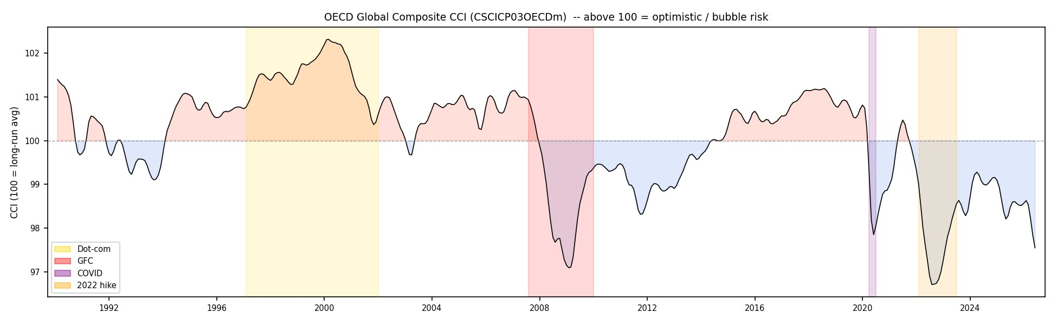
Global OECD CCI 1990 to 2026. Current reading 97.55 (May 2026) — below c1=97.67, the lowest since the GFC. Driven by the April 2025 tariff shock depressing manufacturing and trade confidence globally.

- No bubble detected. The global CCI at 97.55 is below c1=97.67, classifying most markets as MR — the opposite of a bubble
- The AI equity rally of 2023-2024 was never classified as EXP. The S&P 500 gained 50%+ but global consumers were not euphoric — the model correctly distinguishes a narrow technology-driven rally from a genuine broad-based sentiment bubble
- Four phases since 2021: (1) Dec 2021-Feb 2022 — RW, post-COVID rebound. (2) Mar-Oct 2022 — deep MR, synchronised inflation shock, CCI hit 97.10. (3) Nov 2022-Jan 2025 — RW, soft landing and AI rally. (4) Feb-May 2026 — MR returning, tariff shock
- Current MR signal is shallower than 2022 (97.55 vs 97.10), so a more modest recovery than the historical average is expected. The 2022 MR episode was followed by roughly +24% on the S&P 500 in 2023

Market group | Region | Option A | Option B
S&P 500 / TSX / FTSE / STI / SMI | Multiple | MR | RW or MR
Hang Seng / KOSPI / Shanghai / Bovespa | Asia / EM | MR | MR
AEX / IBEX / TA125 / KLCI / IPC | Europe / EM | MR | MR
DAX / CAC40 | Europe | RW | MR
TWSE / JKSE | Asia | RW | RW or MR
Table 5. May 2026 regime classifications. Where A and B disagree, the market is sitting on the threshold boundary (CCI 97.55 just below c1 in A, just above in B).

